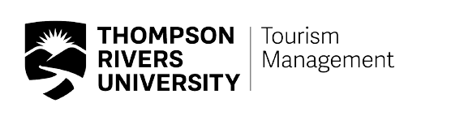
Observation Details

Peer Observation
Feedback

Date/time/location/class size
Faculty observed
Faculty observing
Course information
Topic and format of class

ORGANIZATION
Strengths | Recommendations for improvement

COMMUNICATION SKILLS + VISUAL AIDS

Strengths | Recommendations for improvement

INSTRUCTIONAL STRATEGIES
Strengths | Recommendations for improvement

RAPPORT WITH AND RESPONSIVENESS TO STUDENTS
Strengths | Recommendations for improvement

