Name: Tracy Davison

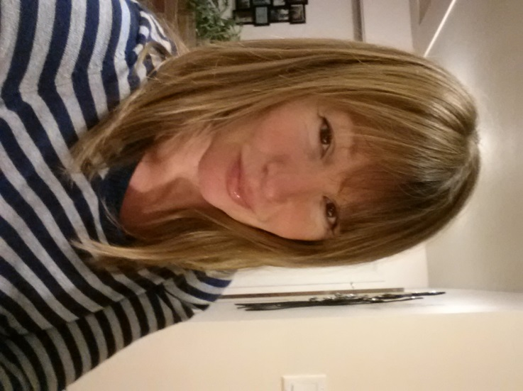
What year did you graduate from TRU?

I graduated in 2011 with a BSW, but was interested in psychology as I think the knowledge gained here is very useful in working with people in social work. I completed the psych major requirements and did the honours program, finishing in Spring of 2014.

What are you doing now?

I started a Masters in Counselling Psychology at Yorkville through correspondence and switched to a Masters in Clinical Social Work on campus at UBC.

How did TRU help you get into grad school, find employment, etc.?

I have found my graduate courses/requirements easy, mainly due to the work I did at TRU in my psychology major and my Honours program. I also am sure this is why i was accepted into my Masters program at UBC, for which there were many applicants. My end goal is to work in a private practice as a counselor. As well, I am interested in policy formation and research.

What did you enjoy about TRU/What did you do while at TRU?

I loved the small classes, selection of courses in the psych program and the great staff at TRU, as well as the ability to do many of my courses through correspondence so that I could work at the same time, paying my way through school. It was nice not having any student loans to pay when I was done.

If current students have questions would you be willing to be contacted:

I would look forward to assisting anyone by answering questions that they may have about education and career plans (1tracydavison@gmail.com)

